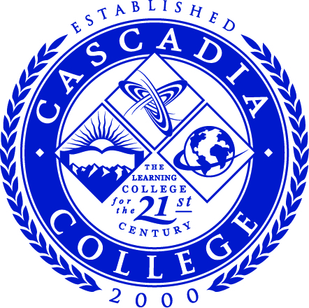

Board of Trustees
Board Regular Meeting (“Summer Retreat”)

Dr. Meghan Quint, Chair

Mr. Alex Lee, Vice Chair

Dr. Rania Hussein

Mr. Shahryar Qadri

Dr. Colleen Ponto

August 19, 2026
9:30 am – 1:30 pm

Cascadia College
CC2-261
18345 Campus Way N.E.
Bothell, WA 98011
CC2-260
Or via Zoom

Cascadia College Board of Trustees
Board Summer Retreat

August 19, 2026
9:30am-1:30pm

Agenda

- CALL TO ORDER

PUBLIC COMMENTS

Cascadia College reserves up to 30 minutes for members of the public to comment on topics related to the meeting’s agenda. Each speaker is allotted up to three minutes to provide their comments.

At the discretion of the Board Chair, comments about topics not on the agenda may be heard. Those who wish to provide comment to the board outside of the agenda’s allotted time or its designated topics may submit their remarks in writing up to seven calendar days after the conclusion of the meeting. Written comments will be distributed to all board members.

- Yearly Board Planning (no Executive Team, no action)
  - Board Appointment Dates
  - Chair & Vice Chair Planning
  - Sub-Committee Planning
  - School Liaisons
  - Policy Review for 26-27
  - Tenure Processes for 26-27 - None
  - Board Self-Evaluation Review

- Discussion Items (w/ Executive Team, no action)
  - Strategic Plan Initiatives for 25-26 & Data Summary
  - Strategic Plan Initiatives for 26-27
  - Accreditation Update

- Working Lunch and Continued Discussion

- Next Regular BOT Meeting – Wednesday, September 16, 2025 @ 4:00 pm

ACCESSIBILITY & NON-DISCRIMINATION

The facilities for this meeting are free of mobility barriers. Interpreters for hearing-impaired individuals and taped information for visually impaired individuals will be provided upon request when adequate notice is given.

Cascadia College is committed to creating a supportive environment for a diverse student, faculty, and staff population. Individual differences are celebrated in a pluralistic community of learners.

Cascadia does not discriminate on based on, but not limited to race, color, national origin, citizenship, ethnicity, language, culture, age, sex, gender identity or expression, sexual orientation, pregnancy or parental status, marital status, actual or perceived disability, use of service animal, economic status, military or veteran status, spirituality or religion, or genetic information in its programs, activities, or employment, and is prohibited from discrimination by college policy and state and federal law.

